LOCATIONS 2015
Frank McCourt Museum
County Limerick
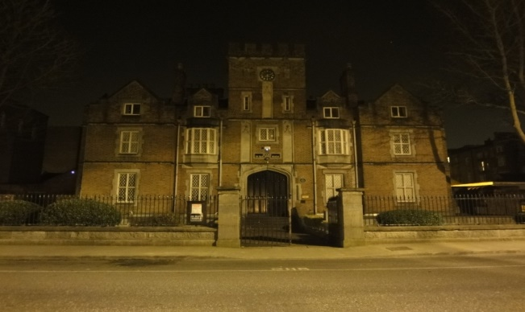
The building was previously known as Leamy House. The Tudor style listed building was built in 1843 with the help of patron William Leamy. It was made into a Protestant boy’s school but with dwindling numbers in 1880 Leamy School became the National School for Catholic boys until 1953. It became a men’s clothing company from 1956-1993. Angela's Ashes author Frank McCourt went to school on this premises.

The Old Thatched Inn
County Cork
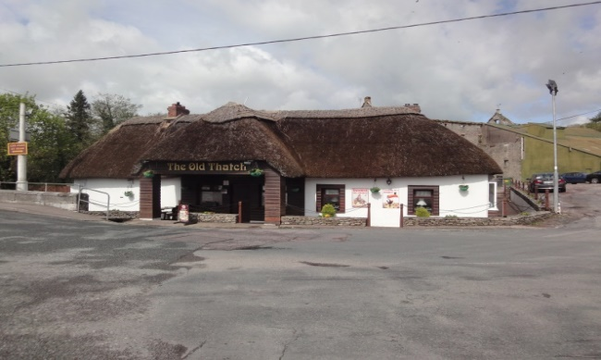
Established in 1665 the Old Thatched Inn is in the list of being Irelands oldest public houses. A former owner John Conway applied for a renewal of license in 1867 at a nearby town Castlemartyr Quarter session. It was refused on the grounds that the premises were being used to harper Fenians. The current owners can trace their ownership of the Bar back to the 1700's. Nearby is a Mill built circa 1790 and Glenbower woods.

Oweynagat Cave and Tulsk Priory
County Roscommon
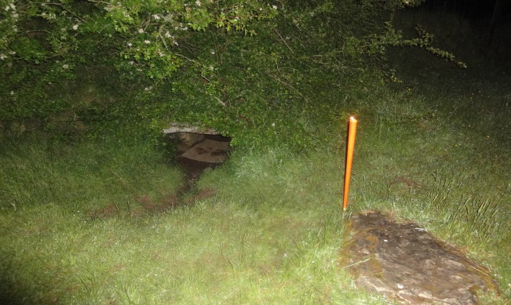
Medieval Tulsk is the oldest and largest unexcavated royal complex in Europe. Cruachan, has over 240 archaeological sites of which 60 are national monuments that cover 4 square miles. Oweynagat is called 'Cave of the Cats'; a hideout for the 'Morrigan' the Goddess of War and Battle. It is 50 metres in length. Tulsk Priory was founded in 1448 and was used by the Dominican Monks.
Ballinamuck 1798 Museum
County Longford
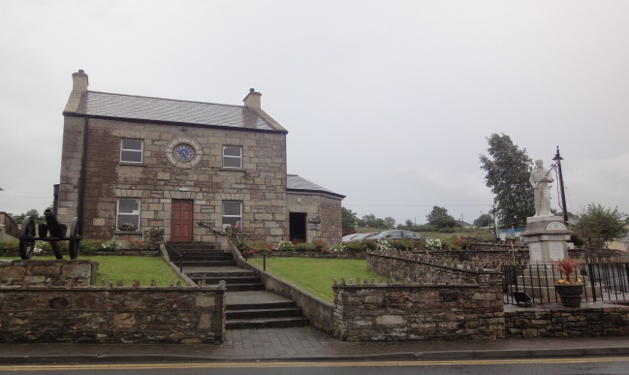
Estimated to been built in 1830 by the King/Harman family. The three bay two storey building has a visitor centre that was opened by Mary McAlesse in 1999. The museum gives detail on the Battle of Ballinamuck, the last war of the rising on Irish soil of 1798. French/Irish soldiers fought against a vast army discharged by the British. A former R.I.C Barracks in later years, it may have also been a Masonic Lodge.

Valentia Lighthouse Fort
County Kerry
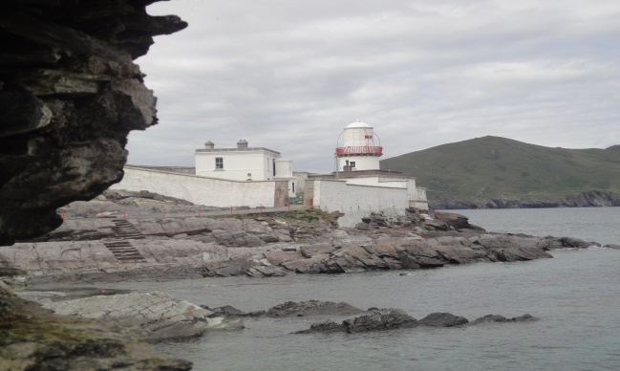
It was formerly known as Cromwell Fleetwood Fort, built as a purpose to protect the passage onto the Island from Pirates and Smugglers. The Fort had 37 Men stationed at the garrison in 1663. The 15 metre Lighthouse was built in 1841 after a declaration by Knight of Kerry Maurice Fitzgerald. Since 1947 the Lighthouse has been automated. Beside the Lighthouse are stone walled Blockhouse Cells which may have housed troops.
Friars Gate Theatre
County Limerick
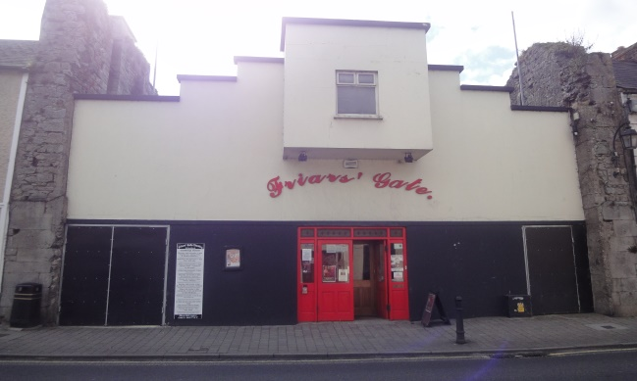
In the heart of the Norman town of Kilmallock is Friars Gate. Found on Sarsfield Street (previous High Street) and is surrounded by many noted buildings. Friars Gate was built (17th century) within the gable walls of Sarsfield House. It used to be a Cinema (circa 1940’s). On the Eastern wall of 1600’s map appears to show a single Tower which gave access at the end of Friars Lane to the Dominican Priory. The Tower was dismantled by the 19th century which the Theatre gets its name to its location.

Bridge Mills
County Galway
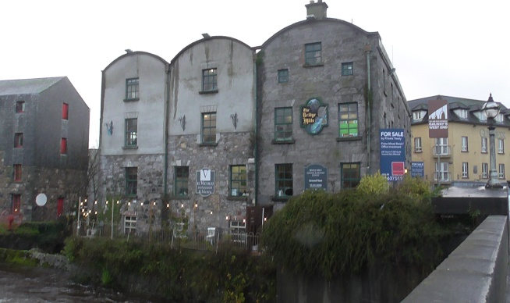
The Bridge Mills is in Galway City on the banks of the River Corrib. It was built around 1558 by Thomas ‘Oge Martin. He was granted the land on condition he would erect a fortified gateway on the Old West Bridge. In August of 1545 the bridge saw an unsuccessful prison break. The prisoners managed to get rid of their irons, plunging into the river evading the guarded Bridge. All were either slayed or hanged on the orders of Sir Richard Bingham.

