LOCATIONS 2016
Athlone Castle
County Westmeath
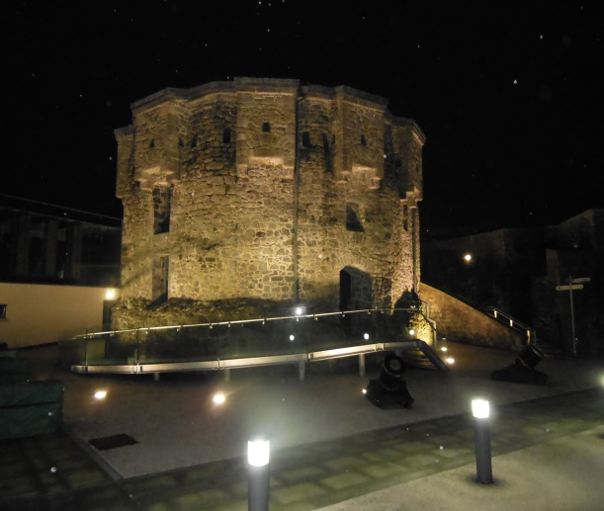
Athlone Castle originally was built in 1129 but the stone structure that survives today was built in 1210 for King John from the orders of John De Gray (Bishop of Norwich). The Castle is shaped polygonal and was constructed on a man-made hill. There were two sieges at the Castle in 1690 and 1691 during the Williamite and Jacobite War. In 1697 the Castle was hit by lightning destroying even more of the fortification.

Rathcroghan Mound and Oweynagat Cave
County Roscommon
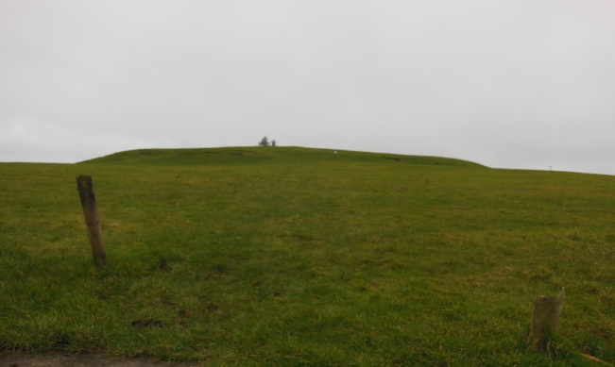
Cruahan is the celebrated seat of the High Kings of Connaught situated a couple of kilometres North-West of the village of Tulsk in County Roscommon. It is one of the four major ancient royal sites. Many Kings are said to be buried on the Mounds in or around the surrounding area. Queen Medb is renowned as the local Earth Goddess. Oweynagat which means ‘The Cave of the Cats’ is said to a portal to the Otherworld.

Inis Cealtra
County Clare
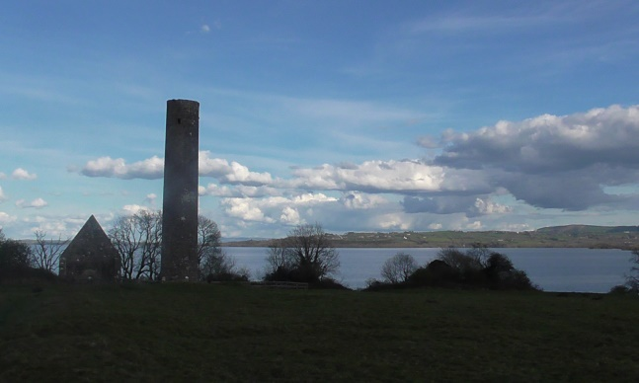
Inis Cealtra is otherwise known as Holy Island. It's situated off Lough Derg 2km from Mountshannon, County Clare. The 50 ache Island is now uninhabited but once was an important monastic settlement. The Islands main focal point is a Round Tower. The cone-cap on top of the Tower is missing. A theory is that the Tower had never been finished or struck by lightning. There are a number of places to visit on the Island which includes a Holy Well.
Clonony Castle
County Offaly
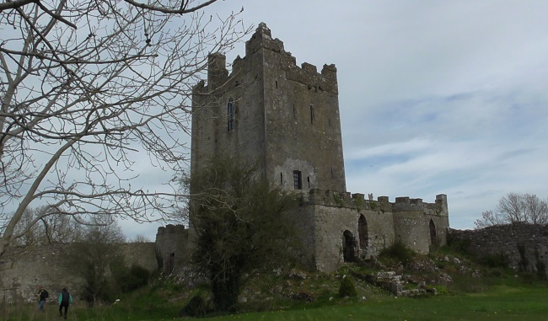
The Tudor Tower House was built by the MacCoughlans in the 1500s. It was relinquished to King Henry VIII by John MacCoghlan then given to Thomas Boleyn when Henry wanted to marry his daughter Anne Boleyn. Mary and Elisabeth Boleyn, great granddaughters of George Boleyn (Anne Boleyn’s brother) lived their lives in the Castle. A tombstone underneath a Hawthorne Tree on the grounds describes their burial.

