CRAFTED
COLOUR MOOD FRAME
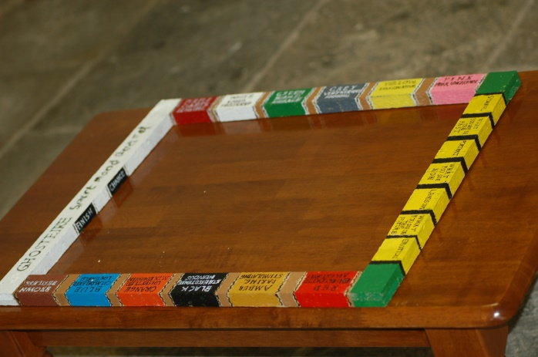
The main aim of the mood frame is to establish communication with an individual Spirit to see what emotion it is in or how we should feel around it. Team members connect on a divination tool (glass or planchette) and ask questions. It takes out the "Are you bad?" and "Do you mean us any harm?" scenario. A more established picture of how the Spirit is feeling is accomplished. Certain colours are used in our daily lives to help us in our routines. For example - red on the board means, 'Alert, adventurous and excited'. This colour is used at traffic lights as a warning to stop, and with road signs with eventual dangers when driving. Light Blue on the board means, 'Calm, relaxed, and lovable’. This colour is used by many of the Hospital fraternity to ease certain pain and to relax a patient’s prognosis. The mood frame has a Yes', 'No', 'Change' and 'Finish' lettering on it. There is a section for pre-planchette drawing divination experiment on one side of the frame. These descriptions help determine what a Spirit will draw.

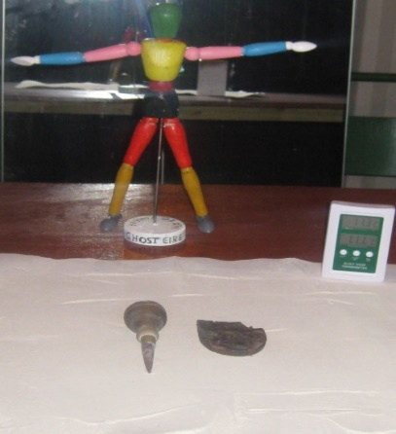
BODY MOOD DOLL
The doll is configured with similar colours to the colour mood frame. The aim is to find out using a divination tool on the frame what injury, illness or area of the body brought about the prognosis of death. The colour on the frame will link to the area of the doll of interest to which the Spirit can relate to. Another use for the doll is when a Spirit can affect a certain area of the body of a team member. It can help pinpoint where a Spirit might touch or affect a person (without them knowing) in a separation vigil elsewhere in a location.

Ogham, Alphistian and Astrology Board
This is a board with differing descriptions of language and
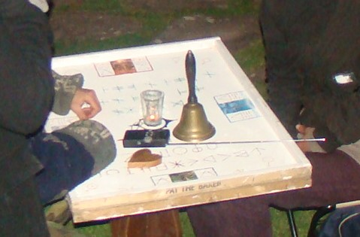
symbols, used as a communication vessel to interact with
Spirits, similar to a talking board (Ouija board). Individuals
using a planchette or any other divination tool can ask
questions on the board, as part of a spiritual experiment.
Ogham writing dates from the fourth to the tenth century. The
‘Celtic tree alphabet’ was native to Ireland and is also linked
to the Brythonic language. The Alphistian language is a
fictional language, made up of Dutch and several Scandinavian
languages, formed by Tony Skaggs in 1967.
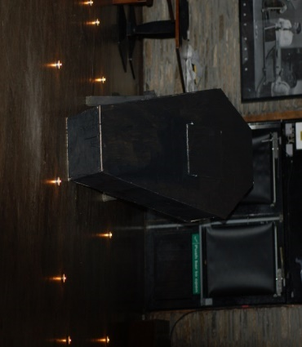
Coffin Sensory Experiment
An individual is closed inside the coffin – either a volunteer
or a person who has been picked during an experiment by the
Spirit world. Whilst that person is in the coffin, the rest of
the team, in another room or area, ask for the Spirit or Spirits
to affect that person or alter the elements around them. Walkie-talkies are handy to relay reactions after changes in
environment have occurred between the person in the coffin and
the rest of the group. Digital recording can help connect the
evidence.
OCCUPATION CARDS
This experiment involves in great detail the Spirits working life. They also can relate to the symbols. On the cards are the old names for old jobs that would have been used from middle ages onwards (for example ‘Fletcher’ was an arrow maker). Some of them are still common today. Using a divination tool the Spirit can pick out what card they find appealing which may give an inkling to how they lived or are still living.

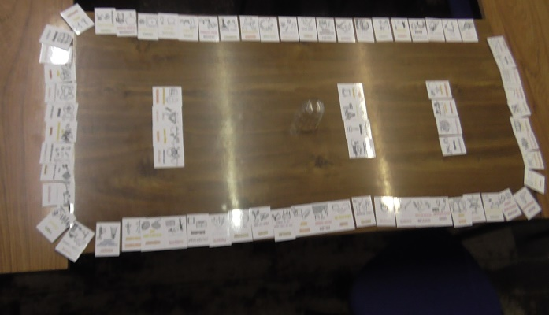
MANIFeSTATION BOARD
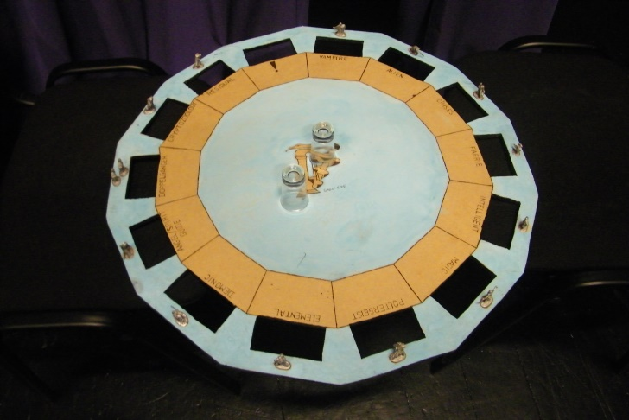
The manifestation board focuses around the different types of energies that we believe to our knowledge exist inside and outside of our realm. The various types of manifestations are represented by thirteen small iron figures on the board, each one spread out into sections. One section of the board lies vacant to account for a type of being unknown to humans. By asking the right questions we are able to find out what is in contact with us, what other energies are around us and what type of entity they think we are. Each section of the board has a (square-hole) cut-off point so the divination tool (such as a glass or planchette) can be disabled from knocking into the miniature figures should a malevolent or energetic Spirit cross our path. So who knows what beings are out there - intelligent, faerie, vampires, or elementals?

THE ALL SEEING EYE PYRAMID SCRYING BOARD
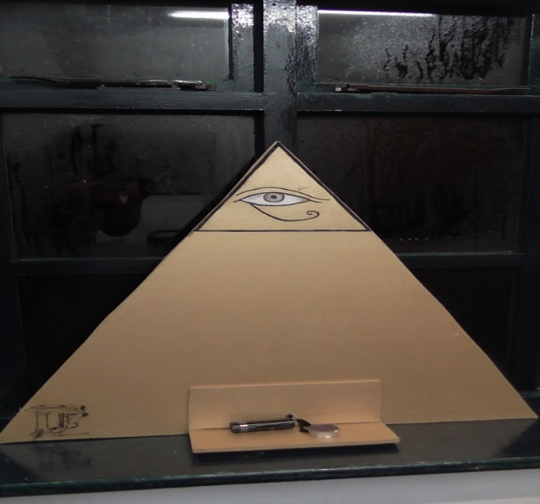
Images of eyes can help avert evil. The use of charms and decorations called ‘Nazars’ are used in West Asian and Mediterranean cultures whilst the ‘Eye of Horus’ was used by Ancient Egyptians to bring protection and for rebirth into the Underworld. The ‘Eye of providence’, an eye inside a triangle is used in Freemasonry. The All Seeing Eye pyramid scrying board is decorated in gold paint. Sticking out at the base of the board is a piece of wood providing the platform for a small mirror and a candle/torch to be placed. Before working with the scrying board we can find with the colour mood frame which reflective colour mirror any Spirits would prefer to come forth in.

AREA BAND BOARD
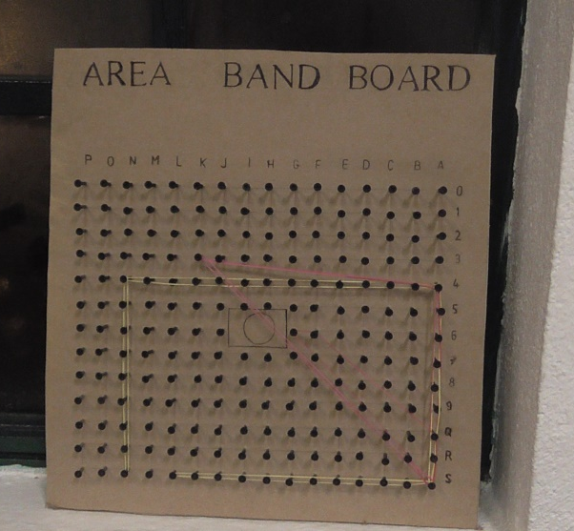
Want to know what is around you in a particular room, floor or area? First, using description cards, nationality cards, occupation cards, individual team member cards and experiment cards we can find out what is most effective, past and present, in a particular part of space. Once a card is identified, we can move onto the area band board, which connects with the talking board. A rough outline of the room/area can be made with elastic bands on the area band board. Next an offering of a number of specific points comes on the talking board, consequently leading to letters and numbers, as a result forming that region. The top horizontal axis has the letters P - A, the right vertical axis has the numbers, 0 - 9, Q, R and S.
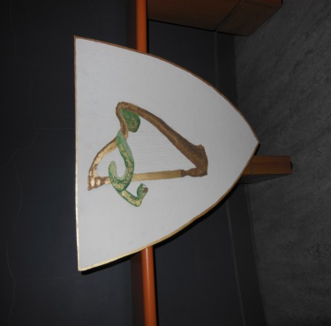
COAT OF ARMS SHIELD
Sometimes you need something to distinguish yourself to what you represent at a location. The GhostÉire coat of arms shield was created by team member Jenifer Kerrigan. The harp represents the symbol of Ireland while the snake represents to pre-Christian times with Paganism. Using this shield as a trigger object is possible too. It lets the ‘Spirits’ know who we are and where we come from. A place such as a castle or a location of a siege or battle is an ideal place to display our colours.

Enochian cards
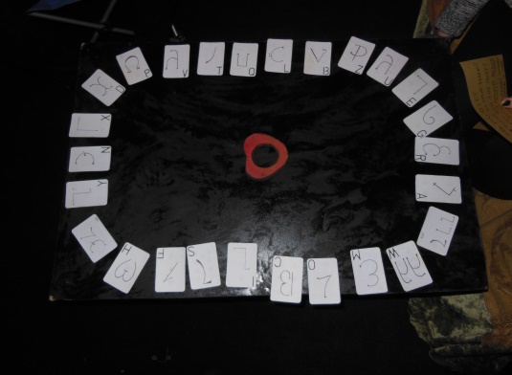
Enochian is the Angelic and Occult language created by Elizabeth I adviser John Dee and colleague Edward Kelly in the late 16th century. Enoch was the last man on earth (before Dee and Kelly) to have known the language. It was claimed to be revealed to spirit medium Kelly using the art of crystal scrying by Enochian angels. It was presumed to have been used by Adam in paradise and was the language used by God to create the world. The Enochian script is written right to left and some of the words are pronounced as they would be in English.

TWELVE LABORS OF HERCULES PLATFORM
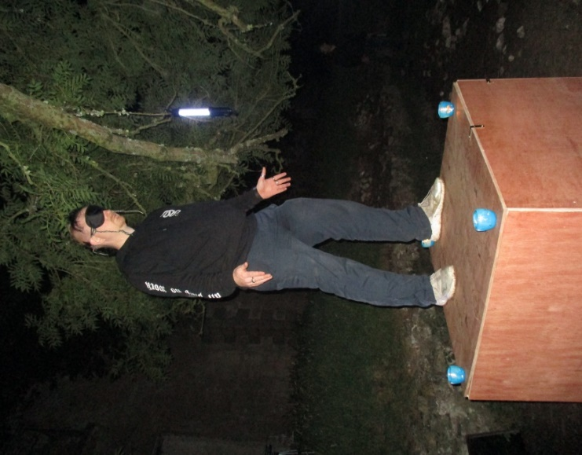
A platform designed for standing on and for divination, consisting of five wooden squares (3ft x 3ft); four raised sides that support a top. An individual stands blindfolded upright on top of the platform. Lack of sight gives the individual a calmer state of mind, which means a longer duration. The sense of floating may be felt. The aim is to pick up on any sound phenomena. The top of the platform has twelve stars. Each star represents one of the labors of Hercules. Before the individual gets on the platform a divination tool is used to discover where the person should be facing, and where the left and right foot should be positioned on the top of the platform. The individual would take up this stance when standing on the platform. Each labor has a penance. So, whatever star the divination tool goes too, might have a link to the history, a passing person, area or the location. For example, Ceryneian Hind means cherishing your body and showing grace.

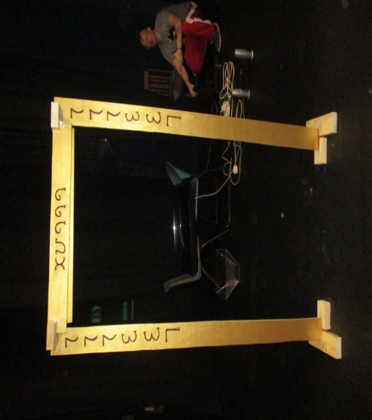
ENOCHIAN DOORWAY
The doorway consists of two vertical planks of wood that form the sides ranging at about six foot and two horizontal planks of wood at the front and back forming the top of the doorway averaging about just over two foot. The doorway is painted in gold with black Enochian wording. The sides of the doorway have the words committed to the team to move objects without the aid of touch. The top of the doorway have the words devoted to protection. The doorway represents a portal in and out of other realms.

PERMISSION BOARD
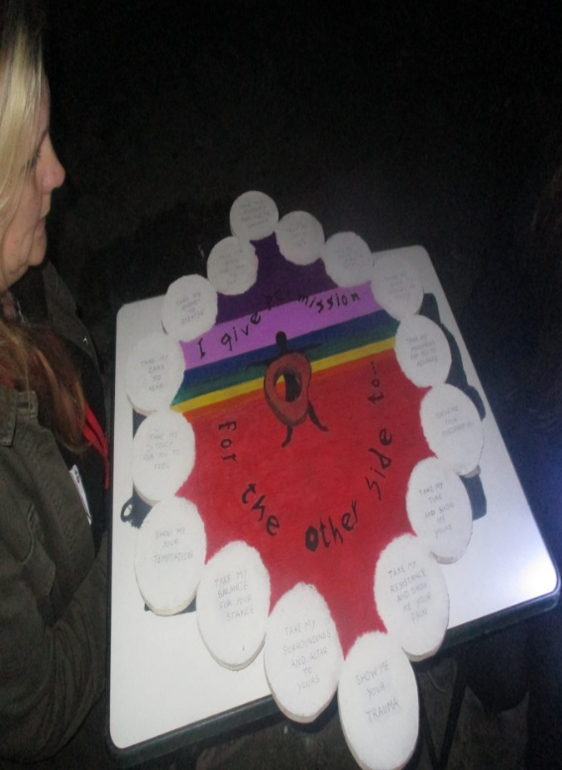
This gives the opportunity to find out how a hesitant or approachable Spirit might alter a team member’s mental and physical condition. A possible reason for a Spirit not coming forward is that consent hasn’t been put forward or another possibility is that they have, but it hasn’t been noticed. The board signifies their intention, making us become more aware. Permission is granted by a person saying, “I give permission of the other side to…” The board has sixteen options for the Spirit to choose from such as, ‘Take my ears to hear’ and ‘Take my movement for you to advance’. As a type of channelling (not possession), it opens up the doors to how the Spirit can influence and for us to access information relevant to the location or the Spirit. Also, this experiment can be done without the individuals knowing the circumstance the Spirit has picked, such as calling out over a walkie-talkie on a separation vigil.
EVP CARDS
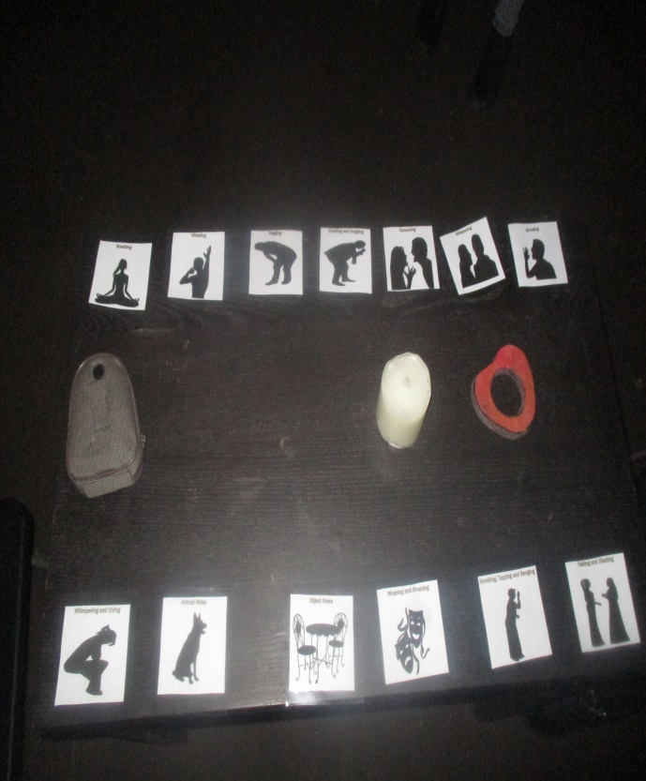
There are a couple of ways in which Electronic Voice Phenomenon can be picked up, either through our own sense of hearing, or by recording devices. Spirits may want to respond to our questions using different methods or display the intense feeling they are in. It’s not just humans that make a noise, but animals and objects too, such as footwear, musical instruments and gunfire to name but a few. These cards could compliment or pinpoint a possible EVP. Each card depicts a type of discernible sound, such as whistling, screaming and so on. Using a divination implement the Spirit could indicate what sound they could produce, other Spirits make and what we should do in a particular area. Done early in an investigation, it offers an likelihood to what sound we should expect.
TORTURE CARDS
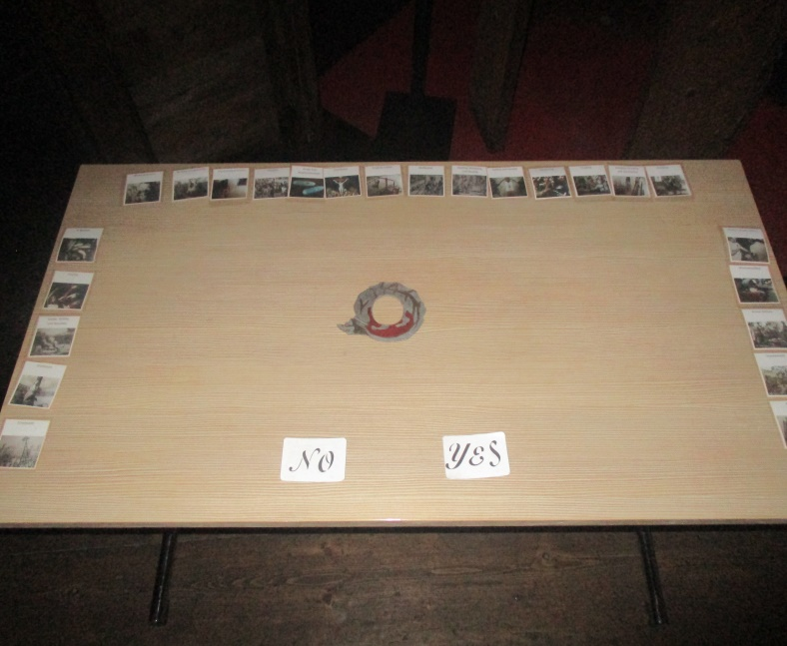
Pain is an essential for survival, but it can be used as an act of cruelty. Torture is used to extract a confession or information. It is thought to be effective in deterring misbehaviour in certain societies. In other cases it can be used for revenge, pleasure or all of the above. Torture is a common method used through history around the world, even in our modern world. The cards include pictures of the various inflictions of pain. Flaying; the stripping of skin, Impalement; the penetration of the body by a sharp object, and Waterboarding; the experience of drowning are just a few tortures displayed in this deck of cards.

DIRECTION MEASUREMENT BOARD
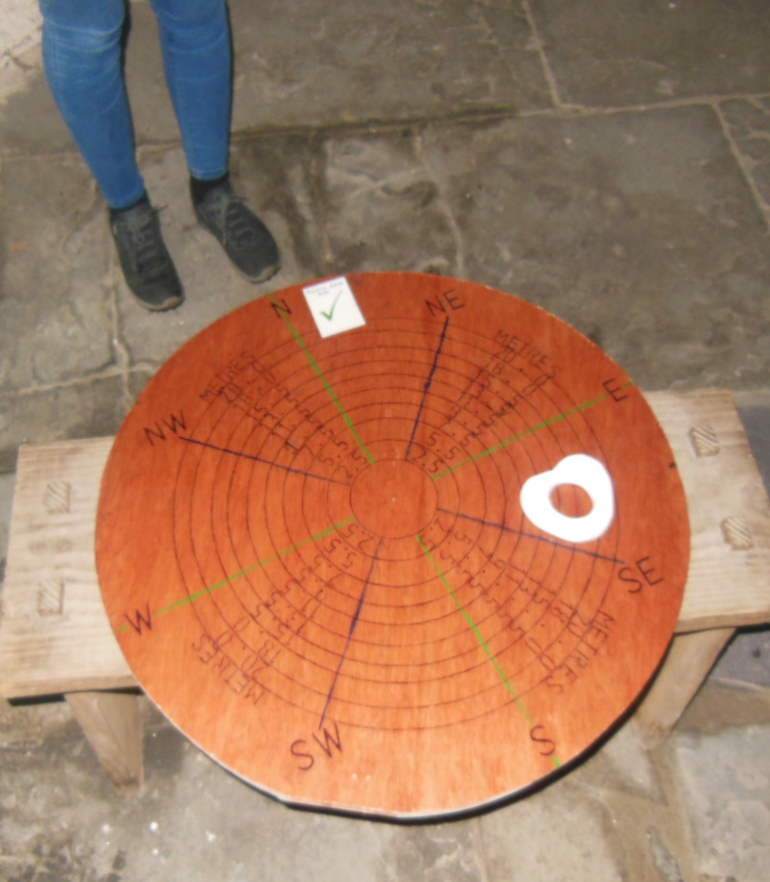
This board has a wide range of utilization. First a compass is used; placed at the centre of the board to verify the correct bearings with the surroundings you are in. A glass/planchette or other divination tool is employed, replacing the compass at the centre. A particular direction (compass points) and measurement (metres) maybe designated by a Spirit - it feels attracted to (depending on what question is asked). Flip the board over and we have the elevation/depth side of the board. This side specialises in distance (metres) above and below. Essential uses for this board is if you’d like to pinpoint where the most active spot is in a building, where to set up equipment/experiments, where a Spirit is, burials, murders, portals and the list goes on. It will give an accurate understanding of the space between two points.

