SOUND
SOUND MONITOR
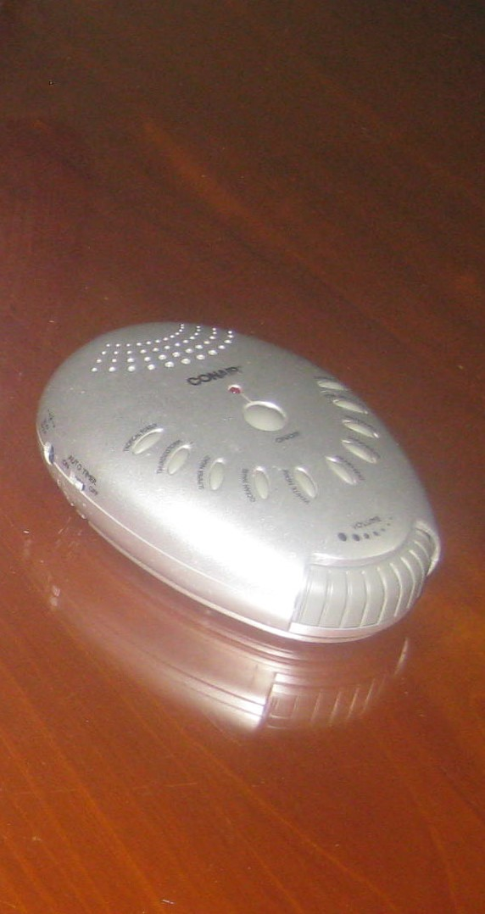
This helps in relaying certain atmospheric sounds to a vigil. Apart from the Heartbeat recording other sounds are included. Thunderstorms, White Noise, Streams, and Rainfall etc. give a pattern to what the energies are familiar with. To promote more activity, it can also add a rhythm that the 'Spirits' can interact with. It helps draw on the spirit vibrations and performs an enactment.

WORKING WITH HERTZ
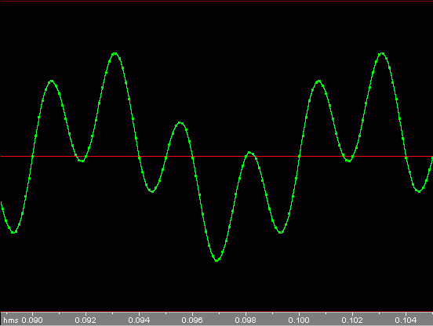
German Physicist Heinrich Hertz made significant contributions to the field of electromagnetism. Sound is a wave of oscillating pressure. The average human can hear from 20 - 16,000 Hertz. Certain frequencies may affect the Spiritual plain, vibrations that humans would probably never hear. As our senses aren't the best in the animal kingdom it is unclear what sound levels ‘Sprits’ can actually communicate in. Creating levels of sound vibration higher than the human hearing (ultrasound) and below the human hearing (Infrasound) can help determine how humans react also in 'Spooky locations' and how in other experiments activity is enhanced or decreased.
COLOUR NOISES
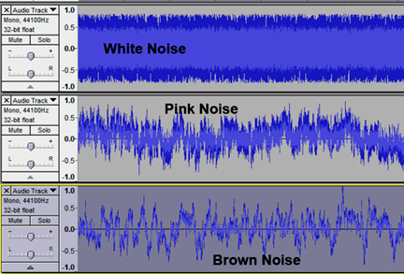
White noise for example is a flat signal fixed within an equal bandwidth. Its ability to cut through normal background noise makes it easier to identify. It is used to stimulate and enhance performance. Working with this in the paranormal world with all the sound frequencies linked into one, we can examine more of the recorded EVP's in a sense much clearer. You can experiment with Pink Noise (also known as flicker noise) is an equal density signal to the intensity of a corresponding size. Red or Brownian Noise has more energy at lower levels, making it sound softer to the human hearing.
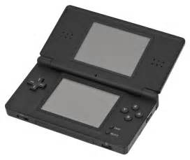
REVERSION AND ALTERED SPEECH
Using a Nintendo DS that has a ten-second record time, a simple question, prayer or chant in any language can be translated and reversed back. The backwards speech may put shivers down your
spine; you may also notice some recognisable wording when you listen back over it. This experiment can be used in séances. It is even more effective when done over a walkie-talkie in
vigils where a team member receiving is alone. It adds another twist. With the Nintendo DS, you can make the reversed recording audible in a high and low pitch and also control its speed.
There are extra features as well that can distort the voice recorded.

Ultrasonic distance meter
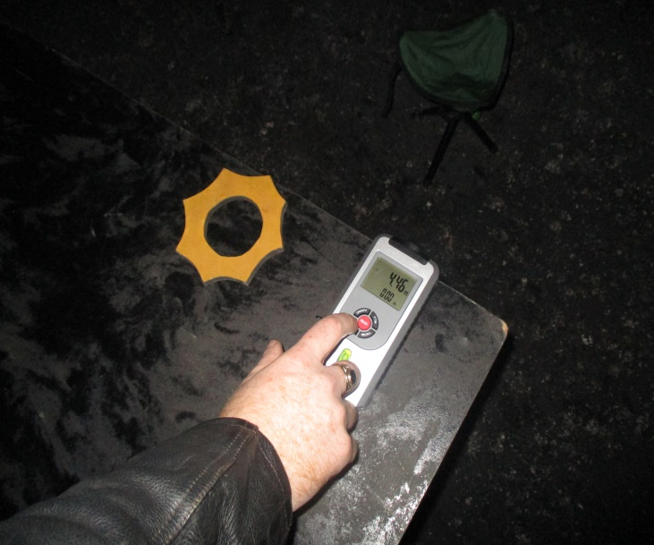
This device measures distances in a straight line using ultrasound (higher than human hearing). It gives a reading with a series of sound waves rebounding off an object, calculating the length of time it takes to come back to the meter. Using this we try to discover if a Spirit can manipulate the distance. First, we find out using a divination tool, the direction the Spirit is in. Then, we direct the meter (kept static) at a target, (preferably a flat surface object, at equal height, as the meter) and record the distance at intervals to see if the distance has changed. If it has, the meter might have moved or the Spirit might be manipulating the sound waves.

MORSE CODE
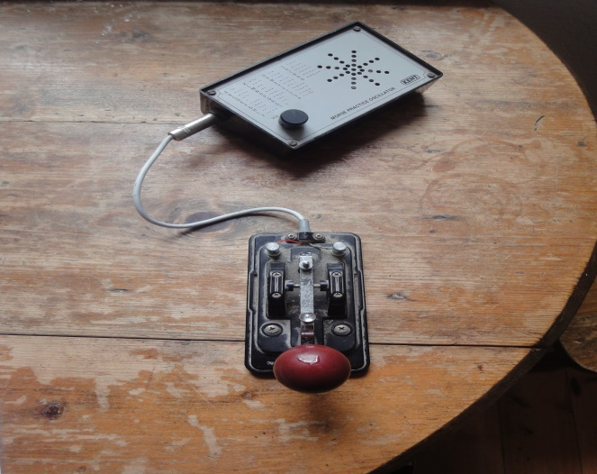
Named after Samuel F. B Morse, a co -inventor of the text code which started in 1836 and who helped develop the use of telegraphy. “Dots” and “Dashes” in short and long consecutive commands are used to communicate either through electrical telegraph transmission or lights. This can be a quite useful experiment if you have questions already setup to be pressed on the knob without calling out. A location of military or navigational heritage would be an ideal place to test this out.
HEARING AIDS
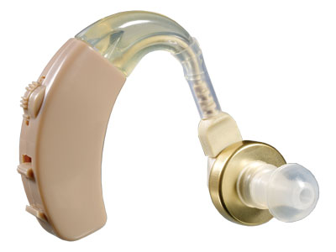
Ear trumpets or ear horns were the first implements used for hearing loss in the 17th century. With the advent of the telephone, the modern day hearing aid progressed and was widely available by the end of the 20th century. Hearing aids today are classified as medical devices. It uses electroacoustic set-up that transfigures external sound to audible for the user. This device manages to pick up discernible sounds on a personal basis to which normal hearing wouldn’t catch. Just like ear phones but being able to
ENOCHIAN BELL DOWSER
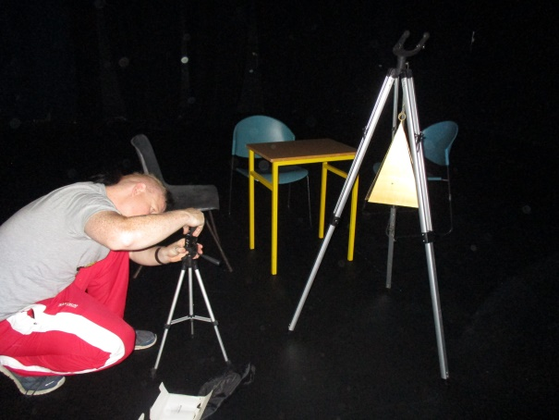
A three sided gold isosceles shaped bell is connected to a five foot tripod by a chain. The clapper (strikes the inside of the bell) is also affixed to a separate chain that leads up inside, to the top of the bell. The chain continues down from the clapper to which a key hangs on the bottom link. Seven black Enochian symbols are inscribed on one side of the bell. This translates for a Spirit to manifest. This experiment can work well as a trigger object, in an enclosed space with a recording device analysing any movement, or hopefully picking up a jingle sound.
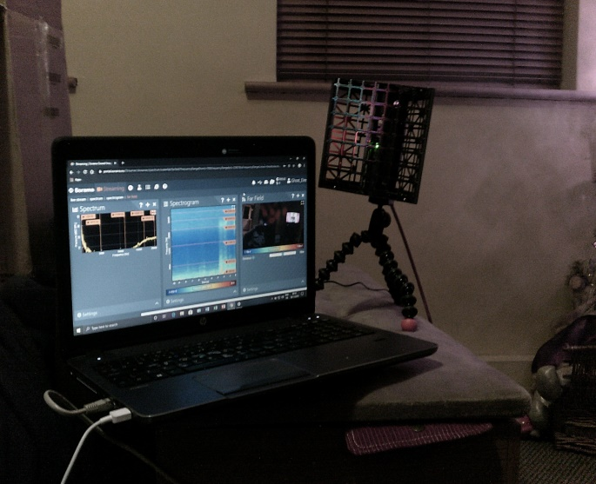
ACOUSTIC CAMERA 64 ARRAY
This flawless piece of kit of equipment arranges sound into vision. It is essential in recognising noise and vibration inconsistencies within a particular space, area or room. The data collected through the device is easily simplified using the wide range of software analysis, such as near and far-field imaging, and time lapse, spectrogram and spectrum features. The handheld assembly has sixty four miniature microphones and a HD camera streaming measurements of below 1 kHz, and up to 20 kHz which can be connected into a laptop or tablet. It also comes with a tripod. It has a simple purpose of distinguishing between Spirit sound occurrences and the usual domestic noise pollution we find in our daily lives.

